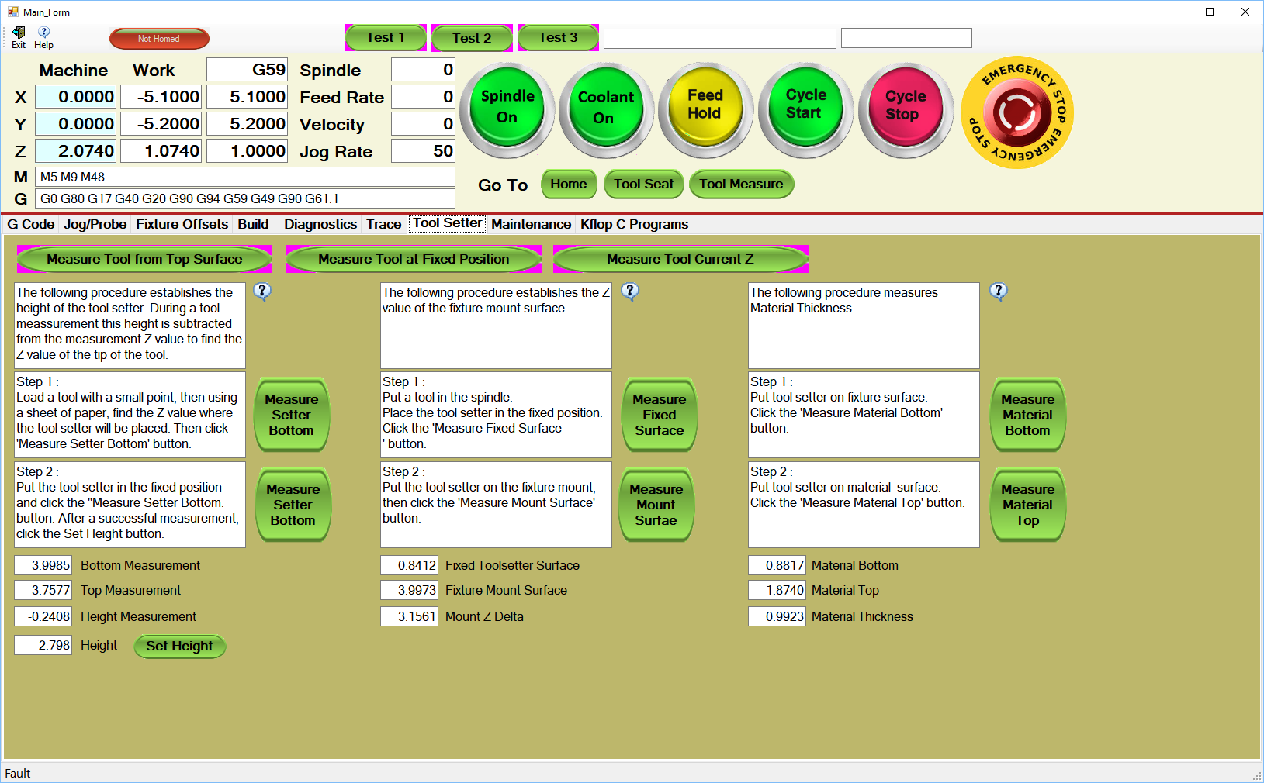

This procedure measures the thickness of material. This is used when using a fixed position tool setter.

First measurement using paper.

Second measurement using tool setter.

Material

Tool Setter

Fixture